MENTORING AGREEMENT (TEMPLATE)
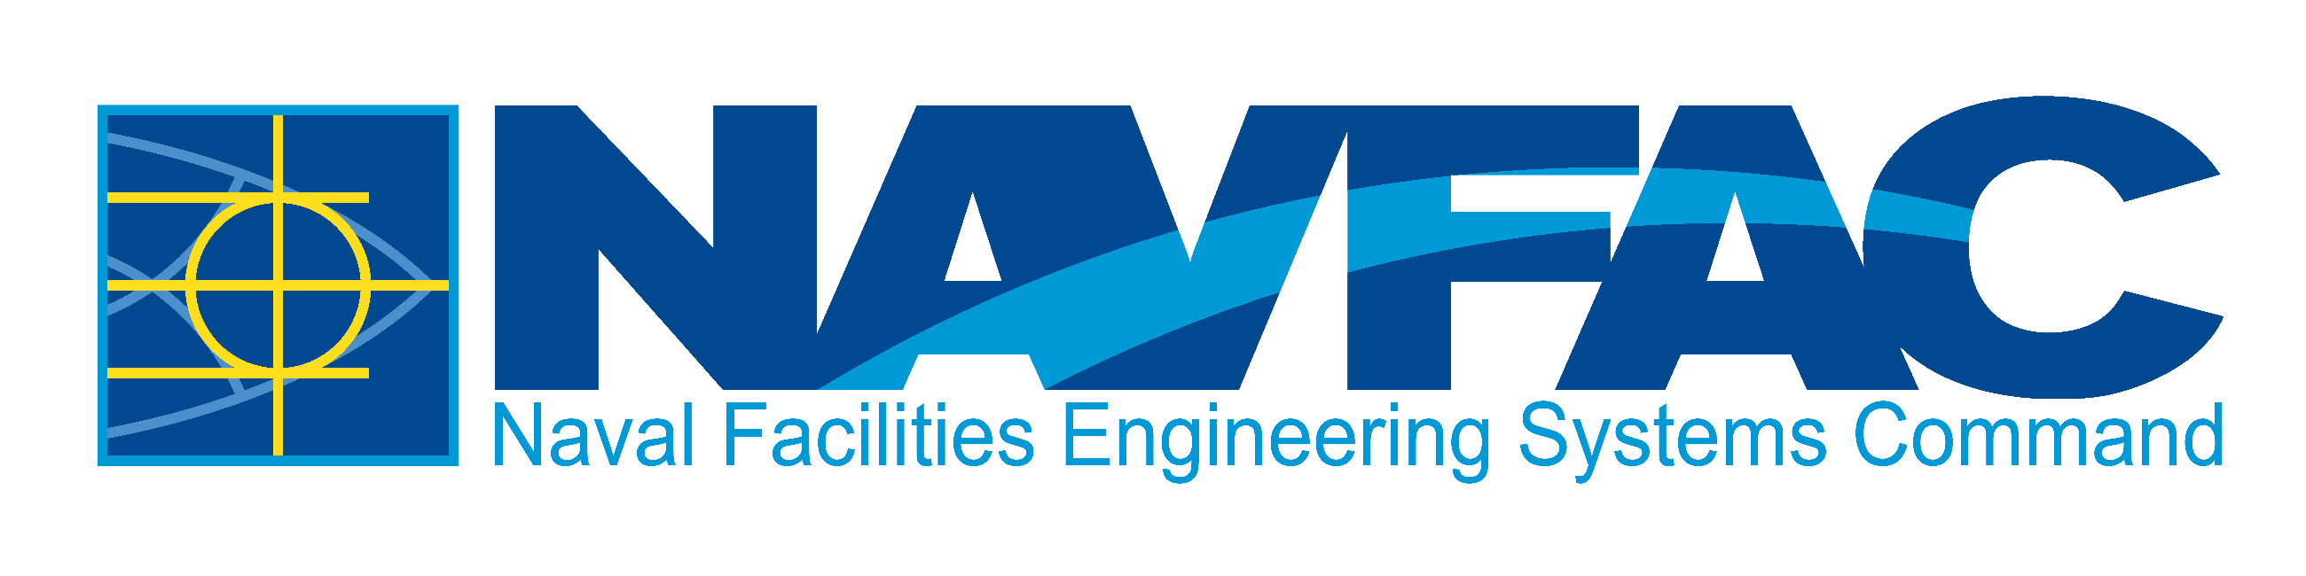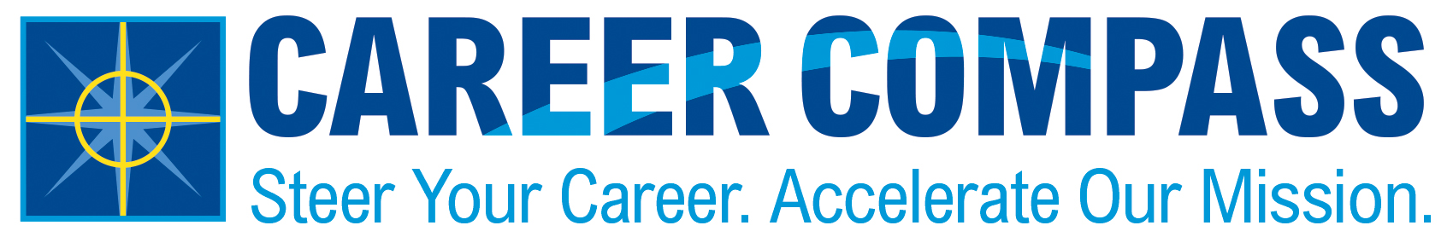

This mentoring agreement helps Mentors and Mentees develop a mutual understanding of expectations from the beginning of their relationship. Additionally, it creates identifiable benchmarks and goals to work towards and evaluate progress.

Note: this agreement is provided in Word format so that the Mentor and/or Mentee may adjust this agreement to fit their needs. Also, completing this agreement is encouraged but not required.

This agreement will help each mentor/mentee pair:
- Establish communication expectations,
- Identify goals for this mentoring relationship, and
- Outline skill areas to be enhanced or developed through this partnership.

As a Mentee, I agree to do the following:

1.
2.
3.
4.
5.

As a Mentor, I agree to do the following:

1.
2.
3.
4.
5.

This agreement outlines the goals and expectations agreed upon by the Mentor and Mentee listed below. We understand that items may be changed or adjusted to fit the needs of both parties as the mentoring relationship grows. This agreement can be revisited as needed. This mentoring relationship is an at-will relationship and both the Mentor and Mentee agree to a no-fault conclusion of this relationship if, for any reason, it seems appropriate.

Mentor Signature |  | Date |  | Mentee Signature |  | Date
Mentor Name |  |  |  | Mentee Name

Closing your Mentoring relationship? Complete the Feedback Form at https://forms.office.com/Pages/ResponsePage.aspx?id=GIdSPm_R6UC2_V2dTYIoKqm1SlyH7fZNgA-rMxPxNvtUMFRGWjA2TDNFR0lMQTBBQlJFTlBCT082NC4u
NAVFAC Mentoring Program Website:
https://www.navfac.navy.mil/Careers/Career-Compass-Workforce-Development/Career-Compass-Resource-Center/Mentoring/
Version: 1.0 Current as of: 22 SEP 2022

